Project Design Phase-II
Technology Stack (Architecture & Stack)
Date | 31 January 2025 | Team ID | 6ab6179bdcoae83adb386708 (Team 6)
Project Name | Auto Ticket Classification using Flow Designer | Maximum Marks | 4 Marks
Technical Architecture:
The architecture includes the application logic, infrastructural boundary, data storage and notification flow required for automatic incident classification and routing. The core solution runs within the ServiceNow platform using Flow Designer.
Architecture Diagram
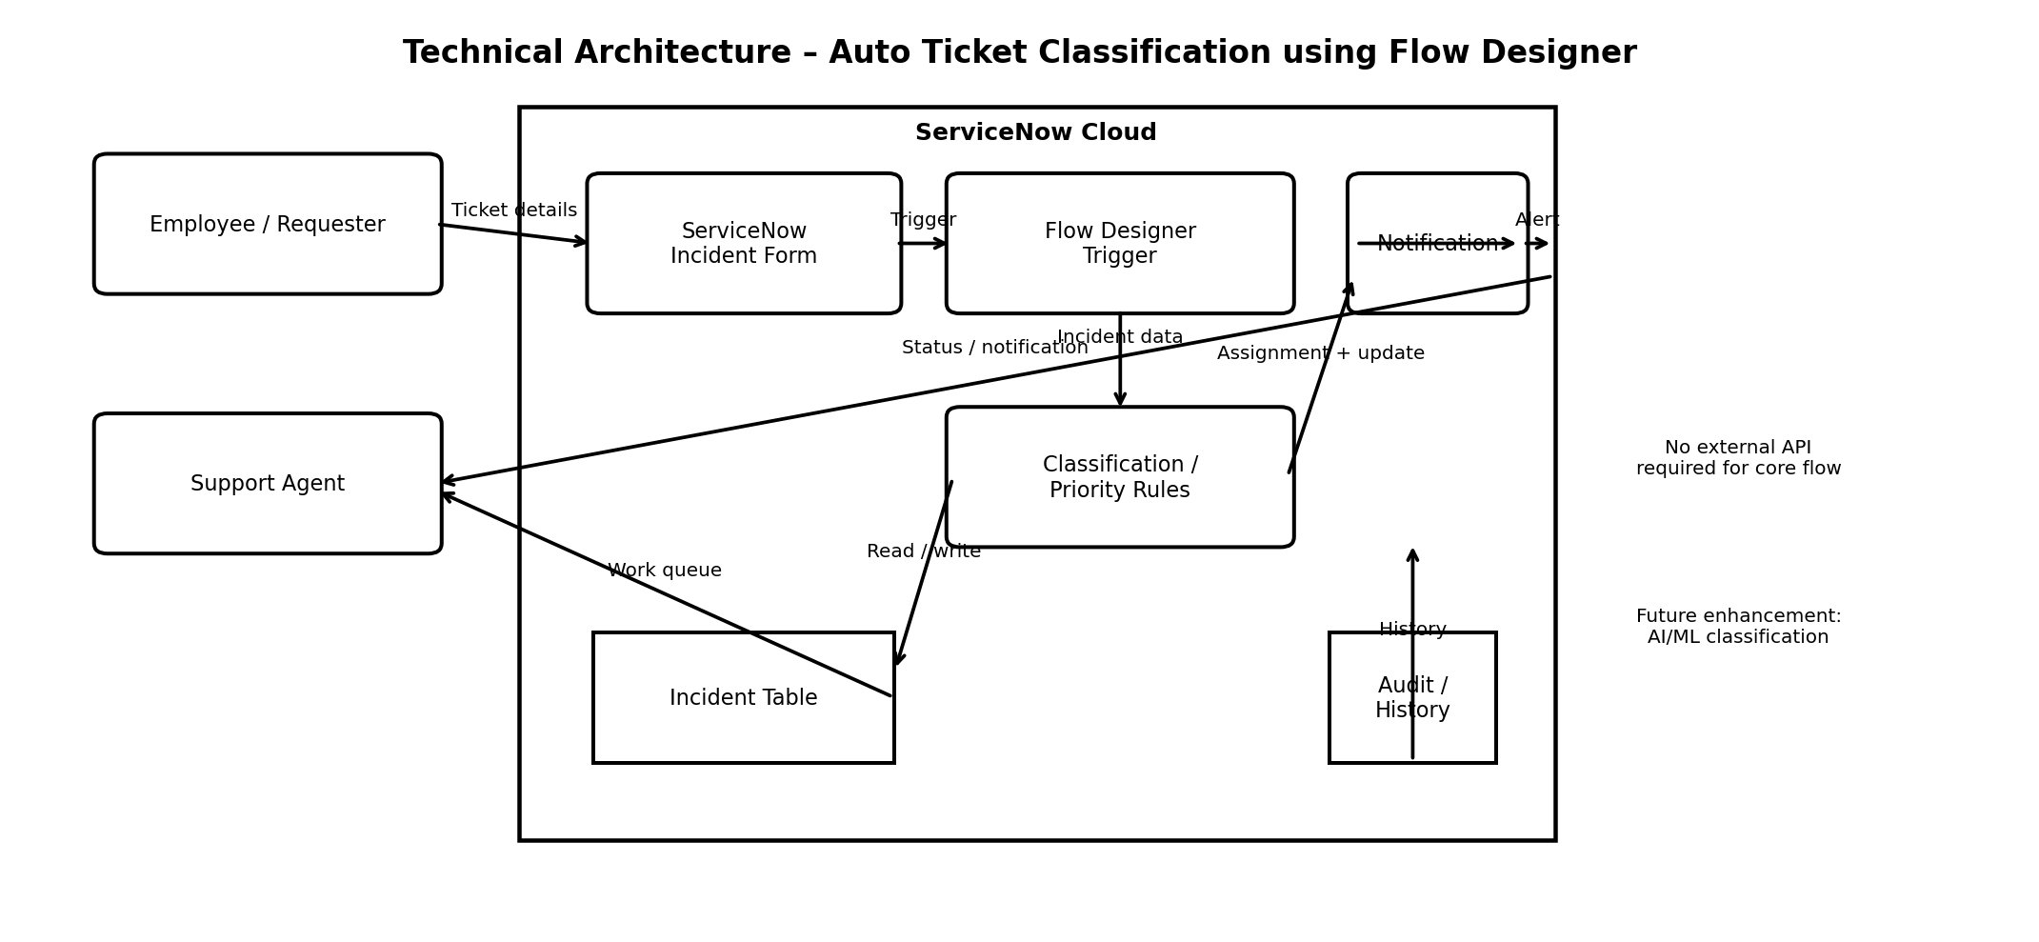
Architecture Guidelines Applied
• Application logic: ServiceNow Incident form, Flow Designer trigger, classification/priority rules and assignment logic.
• Infrastructure: ServiceNow Cloud platform; no separate local server is required for the core implementation.
• External interfaces: ServiceNow notifications/email; no third-party API is required for the core flow.
• Data storage: ServiceNow Incident table and ticket history/audit data.
• Machine learning: Not required for the current rule-based implementation; AI/ML classification can be a future enhancement.
Table-1 : Components & Technologies
S.No | Component | Description | Technology
1 | User Interface | How the user interacts with the application. | ServiceNow Incident Form / ServiceNow UI
2 | Application Logic-1 | Trigger and orchestration logic for a newly created incident. | ServiceNow Flow Designer
3 | Application Logic-2 | Rule-based classification of ticket type from ticket text. | Flow Designer Conditions / Keyword Rules
4 | Application Logic-3 | Priority setting, assignment-group routing and notification logic. | Flow Designer Actions / ServiceNow Business Rules
5 | Database | Stores incident details, category, priority, assignment and status. | ServiceNow Incident Table
6 | Cloud Database | Cloud-hosted platform data storage for the ServiceNow application. | ServiceNow Platform Database
7 | File Storage | Optional attachments such as screenshots or supporting files. | ServiceNow Attachment Storage
8 | External API-1 | Core solution does not require a third-party API. | Not required
9 | External API-2 | Core solution does not require a second third-party API. | Not required
10 | Machine Learning Model | Not used in the current rule-based implementation; reserved for future enhancement. | Not applicable / Future AI-ML
11 | Infrastructure (Server / Cloud) | Application is deployed and executed on the ServiceNow cloud platform. | ServiceNow Cloud
Table-2: Application Characteristics
S.No | Characteristics | Description | Technology
1 | Open-Source Frameworks | The core project uses ServiceNow Flow Designer rather than a separate open-source application framework. | ServiceNow Flow Designer
2 | Security Implementations | Access is controlled through ServiceNow user roles and permissions; incident data is handled within the platform. | ServiceNow Roles / ACLs / HTTPS
3 | Scalable Architecture | Flow-based automation can be extended with additional ticket categories, conditions and assignment groups as volume grows. | ServiceNow Flow Designer
4 | Availability | The solution runs on the ServiceNow cloud platform and uses the platform's managed application environment. | ServiceNow Cloud
5 | Performance | Keep flow conditions focused, avoid unnecessary actions, and automate classification/routing immediately after incident creation. | Flow Designer / ServiceNow Platform
References:
https://c4model.com/
https://developer.ibm.com/patterns/online-order-processing-system-during-pandemic/
https://www.ibm.com/cloud/architecture
https://aws.amazon.com/architecture
https://medium.com/the-internal-startup/how-to-draw-useful-technical-architecture-diagrams-2d20c9fda90d

